**Laporan Praktikum**

**Pemrograman Web 1**

**Dosen pengampu : Yati Nurhayati S.Kom., M.Kom**



**Nama : Bayu Imantoro**

**NIM : 20230810089**

**Kelas : TINFC – 2023 – 04**

**Teknik Informatika**

**Fakultas Ilmu Komputer**

**Universitas Kuningan**

PRAKTIKUM

1. Ketikan Script di bawah ini

<!DOCTYPE html>

<html lang="id">

<head>

<meta charset="UTF-8">

<meta name="viewport" content="width=device-width, initial-scale=1.0">

<title>Form Input Teks</title>

</head>

<body>

<h1>Form Input Data Mahasiswa</h1>

<form method="get" action="M2-1.html">

<table border="0">

<tr>

<td><label for="inputText">Nomor Induk Mahasiswa</label></td>

<td>

<input type="number" id="nim" name="nim" pattern="[0-10]" required>

</td>

</tr>

<tr>

<td><label for="inputText">Nama</label></td>

<td>

<input type="text" id="nama" name="nama" maxlength="30" min="5" size="40" required>

<span>Harus 5-35 karakter</span>

</td>

</tr>

<tr>

<td><label for="inputText">Password</label></td>

<td>

<input type="password" id="pass" name="pass" maxlength="20" min="5" size="40" pattern="(?=.[a-zA-Z])(?=.[0-9])(?=.*[!@#]).+" required />

<span>Harus berisi kombinasi huruf, angka, dan simbol</span>

</td>

</tr>

<tr>

<td><label for="inputText">Nomor Telepon</label></td>

<td>

<input type="tel" id="telp" name="telp" maxlength="12" min="10" pattern="08.*" placeholder="08xxxx" required />

<span>Harus 10-12 karakter</span>

</td>

</tr>

<tr>

<td><label for="inputText">E-Mail</label></td>

<td>

<input type="email" id="e_mail" name="e_mail" placeholder="nama@contoh.com" required />

</td>

</tr>

<tr>

<td><label for="inputText">Alamat</label></td>

<td>

<textarea name="alamat" cols="35" rows="5"></textarea>

</td>

</tr>

<tr>

<td colspan="2">

<button name="save" value="simpan">SIMPAN</button>

<button type="reset" name="cancel" value="batal">BATAL</button>

</td>

</tr>

</table>

</form>

</body>

</html>

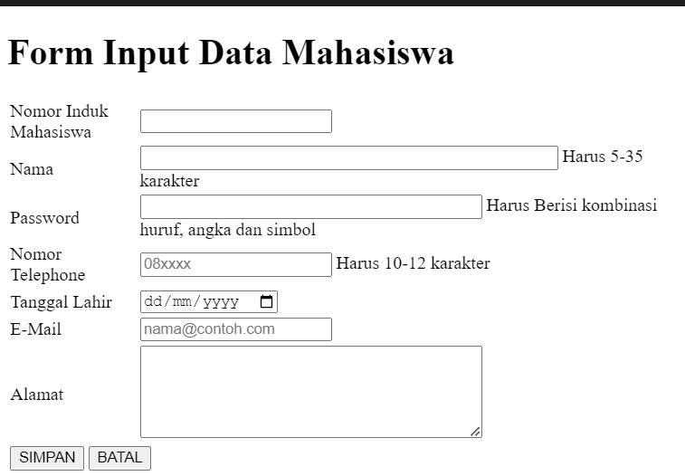

1. Ketikan script di bawah ini

<!DOCTYPE html>

<html lang="en">

<head>

<meta charset="UTF-8">

<meta name="viewport" content="width=device-width, initial-scale=1.0">

<title>Radio Button</title>

</head>

<body>

<h1>Form Pilih Jenis Pembayaran</h1>

<form method="get">

<div>

<label for="input">Pembayaran</label>

</div>

<div>

<input type="radio" id="paymentMethod" name="paymentMethod" value="credit card" />credit card <br> />

<input type="radio" id="paymentMethod" name="paymentMethod" value="debit" checked />Debit <br> />

<input type="radio" id="paymentMethod" name="paymentMethod" value="transfer" />Transfer <br> />

<input type="radio" id="paymentMethod" name="paymentMethod" value="ovo" />Ovo

</div>

<div>

<button name="save" value="simpan">SIMPAN</button>

<button type="reset" name="cancel" value="batal">BATAL</button>

</div>

</form>

</body>

</html>

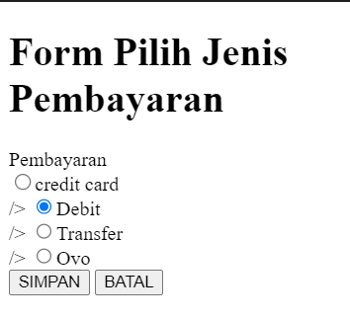

1. <!DOCTYPE html>

<html lang="id">

<head>

<meta charset="UTF-8" />

<meta name="viewport" content="width=device-width, initial-scale=1.0" />

<title>Checkbox</title>

</head>

<body>

<h1>Form Pilih Warna</h1>

<form method="get">

<div>

<label for="input">Warna Kesukaan</label>

</div>

<div>

<input type="checkbox" id="warna" name="warna" value="merah" />Merah <br />

<input type="checkbox" id="warna" name="warna" value="hijau" />Hijau <br />

<input type="checkbox" id="warna" name="warna" value="kuning" />Kuning <br />

<input type="checkbox" id="warna" name="warna" value="biru" />Biru

</div>

<div>

<button name="save" value="simpan">SIMPAN</button>

<button type="reset" name="cancel" value="batal">BATAL</button>

</div>

</form>

</body>

</html>

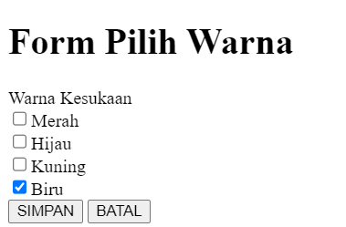

1. <!DOCTYPE html>

<html lang="en">

<head>

<meta charset="UTF-8">

<meta name="viewport" content="width=device-width, initial-scale=1.0">

<title>Dropdown</title>

</head>

<body>

<h1>Form Input Program Studi</h1>

<form method="get">

<div>

<label for="input">Program Studi</label>

</div>

<div>

<select name="prodi">

<option value="-">--Pilih Salah Satu--</option>

<option value="ti" selected>Teknik Informatika</option>

<option value="si">Sistem Informasi</option>

<option value="mi">Manajemen Informatika</option>

<option value="dkv">Desain Komunikasi Visual</option>

<option value="ts">Teknik Sipil</option>

</select>

</div>

<br />

<div>

<button name="save" value="simpan">SIMPAN</button>

<button type="reset" name="cancel" value="batal">BATAL</button>

</div>

</form>

</body>

</html>

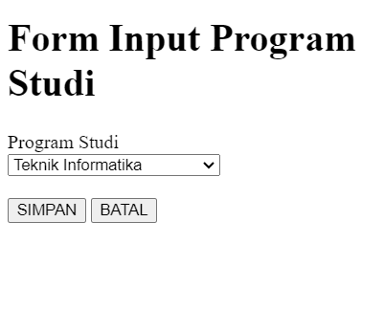

1. <!DOCTYPE html>

<html lang="id">

<head>

<meta charset="UTF-8" />

<meta name="viewport" content="width=device-width, initial-scale=1.0" />

<title>Tombol pada HTML</title>

</head>

<body>

<h1>Form Jenis Tombol</h1>

<form method="get" action="m2-2.html">

<div>

<button name="save" value="simpan" style="background-color: rgb(56, 240, 90)">SIMPAN</button>

</div>

<br />

<div>

<button type="reset" name="cancel" value="batal" style="background-color: yellow">BATAL</button>

</div>

<br />

<a href="m2-3.html">

<button type="button" name="tombol" value="cek" style="background-color: rgb(56, 179, 240)">CEK</button>

</a>

</form>

</body>

</html>

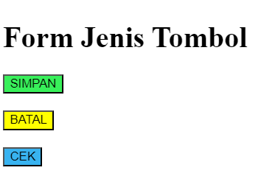

PRETEST

1. Apa perbedaan method get dan post pada <form>?
2. Method get

* **Cara Pengiriman Data**: Data dikirim sebagai bagian dari URL, diapit tanda ? setelah URL dan menggunakan format key=value.
* **Keamanan**: Lebih terbuka dan kurang aman karena data terlihat di URL. Cocok untuk data non-sensitif, seperti pencarian.

1. Method POST

* **Cara Pengiriman Data**: Data dikirimkan di dalam body HTTP request, sehingga tidak terlihat di URL.
* **Keamanan**: Lebih aman daripada GET untuk data sensitif (misalnya, password) karena data tidak terlihat di URL.

1. Jika input nomor telepon, input type apakah yang digunakan?

<input type="tel" name="phone" placeholder="No. anda">

1. Buatkan sebuah form login berisi username dan password serta 1 buah tombol login!

<form action="/login" method="POST">

<label for="username">Username:</label>

<input type="text" id="username" name="username" required>

<label for="password">Password:</label>

<input type="password" id="password" name="password" required>

<button type="submit">Login</button>

</form>

POSTEST

1. Tak input apa uang digunakan untuk melakukan pemilihan dimana pengguna hanya dapat memilih satu saja?

<form>

<label>

<input type="radio" name="option" value="option1"> Option 1

</label>

<label>

<input type="radio" name="option" value="option2"> Option 2

</label>

<label>

<input type="radio" name="option" value="option3"> Option 3

</label>

</form>

1. Buat form untuk tambah data nilai matakuliah yang berisi nama matakuliah, nama dosen, sks, nama mahasiswa, jumlah kehadiran, nilai tugas, nilai quiz, nilai uts, nilai uas, nilai akhir dan niai huruf.

<!DOCTYPE html>

<html lang="id">

<head>

<meta charset="UTF-8">

<meta name="viewport" content="width=device-width, initial-scale=1.0">

<title>Form Tambah Data Nilai Mata Kuliah</title>

</head>

<body>

<h2>Form Tambah Data Nilai Mata Kuliah</h2>

<form action="/submit-nilai" method="POST">

<label for="nama_matakuliah">Nama Mata Kuliah:</label>

<input type="text" id="nama_matakuliah" name="nama_matakuliah" required><br><br>

<label for="nama_dosen">Nama Dosen:</label>

<input type="text" id="nama_dosen" name="nama_dosen" required><br><br>

<label for="sks">SKS:</label>

<input type="number" id="sks" name="sks" min="1" max="6" required><br><br>

<label for="nama_mahasiswa">Nama Mahasiswa:</label>

<input type="text" id="nama_mahasiswa" name="nama_mahasiswa" required><br><br>

<label for="jumlah_kehadiran">Jumlah Kehadiran:</label>

<input type="number" id="jumlah_kehadiran" name="jumlah_kehadiran" min="0" max="16" required><br><br>

<label for="nilai_tugas">Nilai Tugas:</label>

<input type="number" id="nilai_tugas" name="nilai_tugas" min="0" max="100" required><br><br>

<label for="nilai_quiz">Nilai Quiz:</label>

<input type="number" id="nilai_quiz" name="nilai_quiz" min="0" max="100" required><br><br>

<label for="nilai_uts">Nilai UTS:</label>

<input type="number" id="nilai_uts" name="nilai_uts" min="0" max="100" required><br><br>

<label for="nilai_uas">Nilai UAS:</label>

<input type="number" id="nilai_uas" name="nilai_uas" min="0" max="100" required><br><br>

<label for="nilai_akhir">Nilai Akhir:</label>

<input type="number" id="nilai_akhir" name="nilai_akhir" min="0" max="100" required><br><br>

<label for="nilai_huruf">Nilai Huruf:</label>

<select id="nilai_huruf" name="nilai_huruf" required>

<option value="">Pilih Nilai Huruf</option>

<option value="A">A</option>

<option value="B">B</option>

<option value="C">C</option>

<option value="D">D</option>

<option value="E">E</option>

</select><br><br>

<button type="submit">Simpan Data</button>

</form>

</body>

</html>

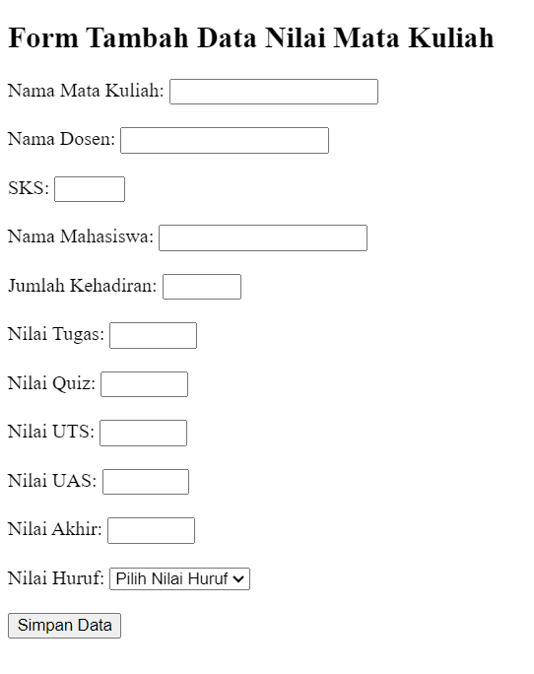

TUGAS

1. HTMLL

<!DOCTYPE html>

<html lang="en">

<head>

<meta charset="UTF-8">

<meta name="viewport" content="width=device-width, initial-scale=1.0">

<title>Form Pemesanan</title>

<link rel="stylesheet" href="styles.css">

</head>

<body>

<div class="container">

<h2>Form Pemesanan</h2>

<form>

<table>

<tr>

<td>Id Pemesan:</td>

<td><input type="number" id="idPemesan" name="idPemesan" placeholder="Masukkan ID Pemesan"></td>

</tr>

<tr>

<td>Nama Pemesan:</td>

<td><input type="text" id="namaPemesan" name="namaPemesan" placeholder="Masukan Nama Pemesan"></td>

</tr>

<tr>

<td>Nomor Identitas:</td>

<td><input type="text" id="nomorIdentitas" name="nomorIdentitas"></td>

</tr>

<tr>

<td>Tipe Kamar:</td>

<td>

<select id="tipeKamar" name="tipeKamar">

<option value="">--Pilih--</option>

<option value="standar">STANDAR</option>

<option value="deluxe">DELUXE</option>

<option value="family">FAMILY</option>

</select>

</td>

</tr>

<tr>

<td>Harga:</td>

<td><input type="text" id="harga" name="harga"></td>

</tr>

<tr>

<td>Tanggal Pesan:</td>

<td><input type="date" id="tanggalPesan" name="tanggalPesan"></td>

</tr>

<tr>

<td>Durasi Menginap:</td>

<td><input type="number" id="durasiMenginap" name="durasiMenginap"></td>

<td>Hari</td>

</tr>

<tr>

<td>Termasuk Breakfast:</td>

<td><input type="checkbox" id="termasukBreakfast" name="termasukBreakfast">Ya</td>

</tr>

<tr>

<td>Total Bayar:</td>

<td><input type="text" id="totalBayar" name="totalBayar" placeholder="Rp"></td>

</tr>

</table>

<div class="buttons">

<button type="submit" class="save">Simpan</button>

<button type="reset" class="cancel">Batal</button>

</div>

</form>

</div>

</body>

</html>

CSS

* {

    box-sizing: border-box;

}

body {

    font-family: Arial, sans-serif;

    background-color: #f3f3f3;

    display: flex;

    justify-content: center;

    align-items: center;

    height: 100vh;

    margin: 0;

}

.container {

    width: 500px;

    padding: 20px;

    background-color: #fff;

    box-shadow: 0px 0px 15px rgba(0, 0, 0, 0.5);

    border-radius: 8px;

}

h2 {

    text-align: center;

    color: #333;

}

form {

    display: flex;

    flex-direction: column;

}

table {

    width: 100%;

    border-collapse: collapse;

    margin-bottom: 20px;

}

td {

    padding: 4px;

    color: #333;

    vertical-align: middle;

}

input[type="text"],

input[type="number"],

input[type="date"],

select {

    padding: 8px;

    border: 1px solid #ccc;

    border-radius: 4px;

    width: 100%;

}

input[type="checkbox"] {

    margin-left: 0;

}

.buttons {

    display: flex;

    justify-content: space-evenly;

}

button {

    padding: 10px 20px;

    border: none;

    border-radius: 4px;

    color: #fff;

    cursor: pointer;

}

button.save {

    background-color: rgb(0, 123, 255);

    box-shadow: 0px 0px 8px rgb(0, 60, 255);

}

button.cancel {

    background-color: #ffc107;

    box-shadow: 0px 0px 8px rgb(255, 174, 0);

}

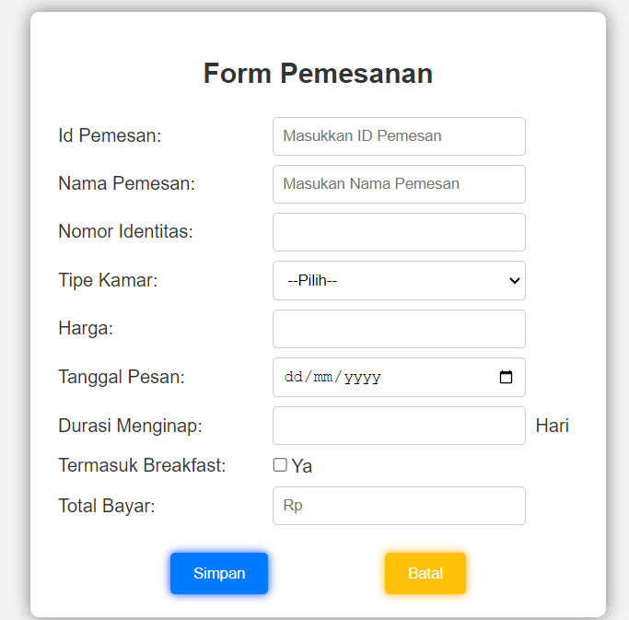

1. Buat form untuk tambah data :
2. Data kamar, berisi : id kamar, gambar ruangan, jenis kamar, harga, fasilitas.

<!DOCTYPE html>

<html lang="id">

<head>

<meta charset="UTF-8">

<meta name="viewport" content="width=device-width, initial-scale=1.0">

<title>Form Input Teks</title>

<style>

.form-box {

width: 600px;

padding: 10px;

border: 1px solid #ccc;

border-radius: 8px;

box-shadow: 0 4px 8px rgba(0, 0, 0, 0.1);

margin: 0;

background-color: rgb(245, 245, 245);

h1 {

text-align: left;

}

.table1, .table2 {

margin-left: 5px;

margin-right: 30px;

}

td {

padding: 10px;

}

}

.buton1 {

cursor: pointer;

}

</style>

</head>

<body>

<div class="form-box">

<h1>Tambah Data Kamar</h1>

<form action="/submit-data-kamar" method="post" enctype="multipart/form-data">

<table class="table1">

<tr>

<td><label for="IdKamar">Id Kamar</label></td>

<td>

<input type="number" id="Id" name="Id" min="1" max="10" style="width: 97%;" required>

</td>

</tr>

<tr>

<td><label for="GambarRuangan">Gambar Ruangan</label></td>

<td>

<input type="file" id="GambarRuangan" name="GambarRuangan" accept="image/*" required>

</td>

</tr>

<tr>

<td><label for="JenisKamar">Jenis Kamar</label></td>

<td>

<input type="text" id="JenisKamar" name="JenisKamar" size="40px" required>

</td>

</tr>

<tr>

<td><label for="harga">Harga</label></td>

<td>

<input type="number" id="Harga" name="harga" style="width: 97%;" required>

</td>

</tr>

<tr>

<td><label for="Fasilitas">Fasilitas</label></td>

<td>

<textarea name="Fasilitas" id="Fasilitas" rows="3" placeholder="Fasilitas" required></textarea>

</td>

</tr>

<tr>

<td>

<button class="buton1" type="submit" required >Kirim Data Ruangan</button>

</td>

</tr>

</form>

</div>

</body>

</html>

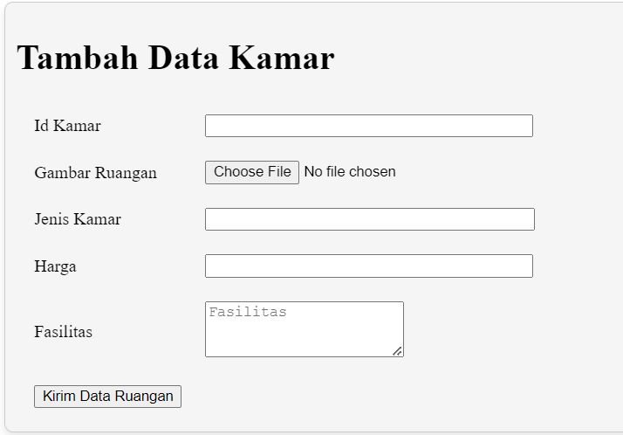

1. Fasilitas, berisi : id, nama, fasilitas, harga weekend, harga weekday, kuota, jam tutup

<!DOCTYPE html>

<html lang="id">

<head>

<meta charset="UTF-8">

<meta name="viewport" content="width=device-width, initial-scale=1.0">

<title>Form Input Teks</title>

<style>

.form-box {

width: 600px;

padding: 10px;

border: 1px solid #ccc;

border-radius: 8px;

box-shadow: 0 4px 8px rgba(0, 0, 0, 0.1);

margin: 0;

background-color: rgb(245, 245, 245);

h1 {

text-align: left;

}

.table1, .table2 {

margin-left: 5px;

margin-right: 30px;

}

td {

padding: 10px;

}

}

.buton1 {

cursor: pointer;

}

</style>

</head>

<body>

<div class="form-box">

<h1>Tambah Data Fasilitas</h1>

<form action="/submit-Facility-data" method="post" enctype="multipart/form-data">

<table>

<tr>

<td><label for="inputId">Id Fasilitas</label></td>

<td>

<input type="number" id="id" name="id" maxlength="30" style="width: 97%;" required>

</td>

</tr>

<tr>

<td><label for="NamaFasilitas">Nama Fasilitas</label></td>

<td>

<input type="text" id="NamaFasilitas" name="NamaFasilitas" size="40px" required>

</td>

</tr>

<tr>

<td><label for="DeskripsiFasilitas">Deskripsi Fasilitas</label></td>

<td>

<textarea type="text" id="Deskripsi" name="Deskripsi" rows="3" placeholder="deskripsi" required></textarea>

</td>

</tr>

<tr>

<td><label for="HargaWeekend">Harga (Weekend)</label></td>

<td>

<input type="number" id="HargaWn" name="hargaWn" style="width: 97%;" required>

</td>

</tr>

<tr>

<td><label for="HargaWeekday">Harga (Weekday)</label></td>

<td>

<input type="number" id="HargaWd" name="hargaWd" style="width: 97%;" required>

</td>

</tr>

<tr>

<td><label for="Quota">Quota</label></td>

<td>

<input type="number" id="Quota" name="Quota" min="1" max="10" style="width: 97%;" required>

</td>

</tr>

<tr>

<td><label for="JamBuka">Jam Buka</label></td>

<td>

<input type="time" id="JamBuka" name="JamBuka" required>

</td>

</tr>

<tr>

<td><label for="JamTutup">Jam Tutup</label></td>

<td>

<input type="time" id="JamTutup" name="JamTutup" required>

</td>

</tr>

<tr>

<td>

<button class="buton1" type="submit" required >Kirim Data Fasilitas</button>

</td>

</tr>

</form>

</div>

</body>

</html>

